DEPARTMENT OF

COMPUTER SCIENCE & ENGINEERING

 | Experiment 2
Student Name: Pratik Kaushal |  | UID:22BCS10026
Branch: BE-CSE |  | Section/Group:DL-902-A
Semester:6th |  | Date of Performance:17 JAN
Subject Name: Project Based Learning |  | Subject Code: 22CSH-359
in Java with Lab

- Aim: The aim of this project is to design and implement a simple inventory

control system for a small video rental store. Define least two classes: a class Video to model a video and a class VideoStore to model the

actual store.

Assume that an object of class Video has the following attributes:

  - A title;

  - a flag to say whether it is checked out or not;

  - An average user rating.

Add instance variables for each of these attributes to the Video class.

In addition, you will need to add methods corresponding to the following:

- being checked out;

- being returned;

- receiving a rating.

The VideoStore class will contain at least an instance variable that references an array of videos (say of length 10). The VideoStore will contain the following methods:

- addVideo(String): add a new video (by title) to the inventory;

- checkOut(String): check out a video (by title);

- returnVideo(String): return a video to the store;

- receiveRating(String, int) : take a user's rating for a video; and 5. listInventory(): list the whole inventory of videos in the store.
DEPARTMENT OF
COMPUTER SCIENCE & ENGINEERING

- Objective: Create a VideoStoreLauncher class with a main() method which will test the functionality of your other two classes. It should allow the following.

  - Add 3 videos: "The Matrix", "Godfather II", "Star Wars Episode IV: A New Hope".

  - Give several ratings to each video.

  - Rent each video out once and return it.

List the inventory after "Godfather II" has been rented out.

- Implementation/Code:

  - Video Class:-class Video {

private String title;

private boolean checkedOut; private double averageRating; private int ratingCount;

public Video(String title) {

this.title = title;

this.checkedOut = false;

this.averageRating = 0.0;

this.ratingCount = 0;

}

public void checkOut() {

if (!checkedOut) {

checkedOut = true;

System.out.println("Video \"" + title + "\" has been checked out."); } else {

System.out.println("Video \"" + title + "\" is already checked out.");

}

}
DEPARTMENT OF
COMPUTER SCIENCE & ENGINEERING

public void returnVideo() {

if (checkedOut) {

checkedOut = false;

System.out.println("Video \"" + title + "\" has been returned."); } else {

System.out.println("Video \"" + title + "\" was not checked out.");

}

}

public void receiveRating(int rating) {

if (rating < 1 || rating > 5) {

System.out.println("Invalid rating. Please rate between 1 and 5."); return;

}

averageRating = (averageRating * ratingCount + rating) / (++ratingCount);

System.out.println("Received rating of " + rating + " for video \"" + title + "\".");

}

public String getTitle() {

return title;

}

public boolean isCheckedOut() {

return checkedOut;

}

public double getAverageRating() {

return averageRating;

}

}
DEPARTMENT OF
COMPUTER SCIENCE & ENGINEERING

- VideoStore Class:-class VideoStore {

private Video[] videos; private int count;

public VideoStore(int capacity) {

videos = new Video[capacity];

count = 0;

}

public void addVideo(String title) {

if (count < videos.length) {

videos[count++] = new Video(title);

System.out.println("Added video: " + title);

} else {

System.out.println("Inventory is full. Cannot add more videos.");

}

}

public void checkOut(String title) {

Video video = findVideo(title);

if (video != null) {

video.checkOut();

} else {

System.out.println("Video \"" + title + "\" not found.");

}

}

public void returnVideo(String title) {

Video video = findVideo(title);

if (video != null) {

video.returnVideo();

} else {

System.out.println("Video \"" + title + "\" not found.");

}

}
DEPARTMENT OF
COMPUTER SCIENCE & ENGINEERING

public void receiveRating(String title, int rating) { Video video = findVideo(title);

if (video != null) {

video.receiveRating(rating);

} else {

System.out.println("Video \"" + title + "\" not found.");

}

}

public void listInventory() {

System.out.println("\nInventory:");

for (int i = 0; i < count; i++) {

Video video = videos[i];

System.out.println("Title: " + video.getTitle() + ", Checked Out: " + video.isCheckedOut() +

", Average Rating: " + video.getAverageRating());

}

}

private Video findVideo(String title) {

for (int i = 0; i < count; i++) {

if (videos[i].getTitle().equalsIgnoreCase(title)) { return videos[i];

}

}

return null;

}

}
DEPARTMENT OF
COMPUTER SCIENCE & ENGINEERING

- VideoStoreLauncher Class:-public class VideoStoreLauncher {

public static void main(String[] args) { VideoStore store = new VideoStore(10);

store.addVideo("The Matrix");

store.addVideo("Godfather II");

store.addVideo("Star Wars Episode IV: A New Hope");

store.receiveRating("The Matrix", 5); store.receiveRating("Godfather II", 4); store.receiveRating("Star Wars Episode IV: A New Hope", 5);

store.checkOut("Godfather II");

store.returnVideo("Godfather II");

store.listInventory();

}

}

4. Output:
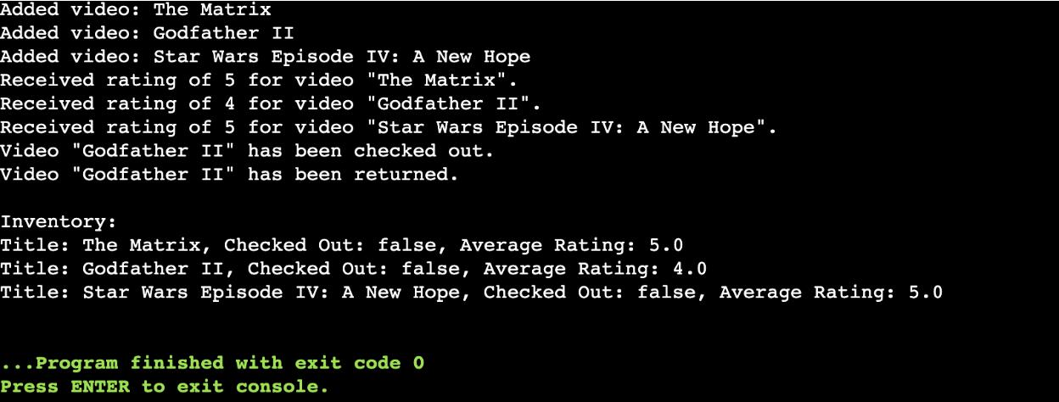
DEPARTMENT OF
COMPUTER SCIENCE & ENGINEERING

- Learning Outcomes:

  - Designed a functional system to manage video rentals, demonstrating the use of classes and objects in Java.

  - Implemented methods for operations like adding videos, renting out, returning, and recording user ratings.

  - Applied arrays to store and efficiently manage the video inventory within the store.

  - Learned to integrate multiple classes and enable seamless interaction among them in a structured program.

  - Strengthened understanding of object-oriented programming concepts like encapsulation and method abstraction.

